DAA OUTPUT

1).Implementation and Performance Analysis of Interpolation Search
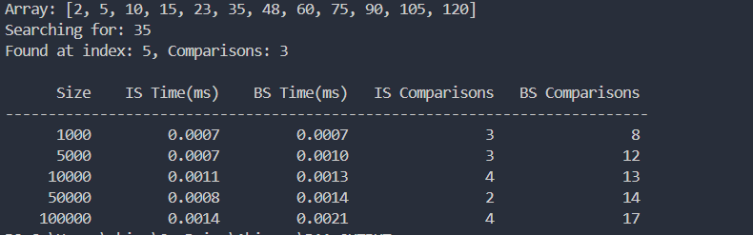

2).Comparative Analysis of Naive, Rabin-Karp, and KMP Algorithms for String Matching
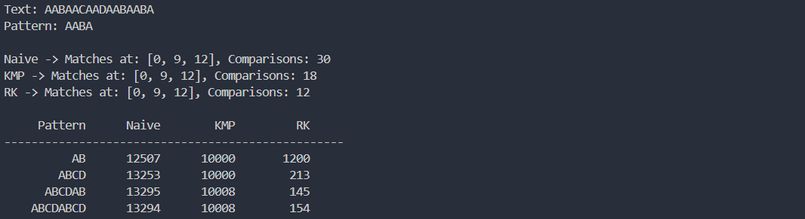

3).Implementation of Kruskal's and Prim's Algorithms for Minimum Spanning Tree

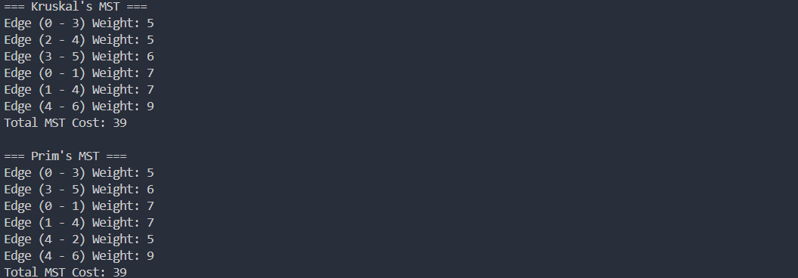

4).Implementation of Single Source Shortest Path Algorithm (Dijkstra's)

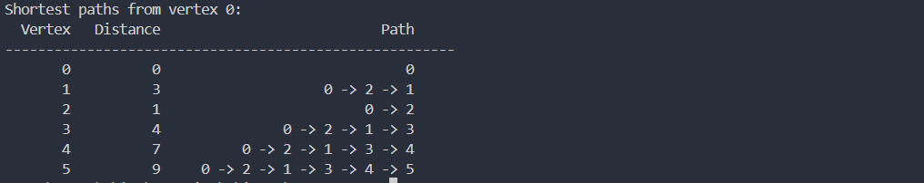
5).To find the MIN-Max by applying Divide and Conquer technique

